## Final Architectural Plan

Prepared for Michael Landreth

Project Mentality

Prepared by Carson Perry

|  |
| --- |
| Design Planning Summary |

1. This development project is the result of the lack of mental illness awareness within kids and the harm that it may cause in interpersonal relationships with those that suffer from mental illnesses. This project will help alleviate those issues by providing a game to help people understand the perspectives of those with the included mental illnesses. This game will be comprised of multiple levels that depict a different mental illness. The player will go through these levels as a character with that mental illness. I believe that video games are the perfect medium for relaying perspective. Someone can talk about their experiences, but it’s still difficult to see their perspective and be in their shoes, especially when their brain works in a fundamentally different way. However, with a video game, the player is able to act as someone with that illness and see things that translate well into the symptoms of those mental illnesses. This is a much easier way to change perspective.

|  |
| --- |
| Overview of Design Concepts |

1. The User will select a level in the main menu, then be loaded into the level. Not all levels will have a UI. In fact, the OCD level is the only level with planned UI outside of text appearing at the bottom of the screen for dialogue. Minimal UI is to help with immersion, however with the OCD design, the UI serves the purpose of placing a sense of importance of the objectives of a typical morning, though there’s no real reason to do the tasks in that order, and it’s purely in the players head that they need to do those tasks in that order, just as someone with OCD thinks. The UI for that level serves the purpose of furthering perspective in the players head.

UI Screenshots

* 1. Main Menu: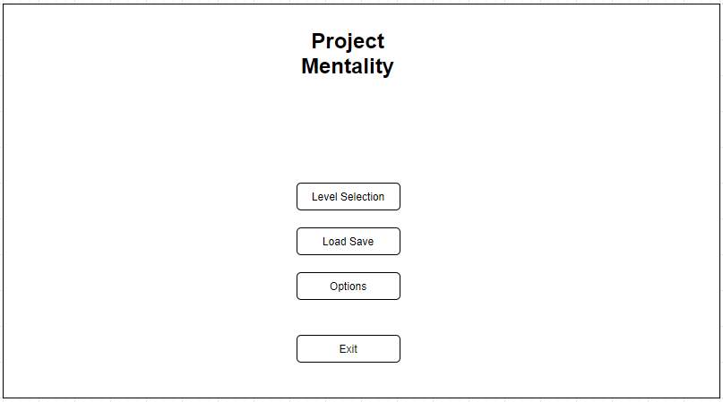
  2. OCD Level: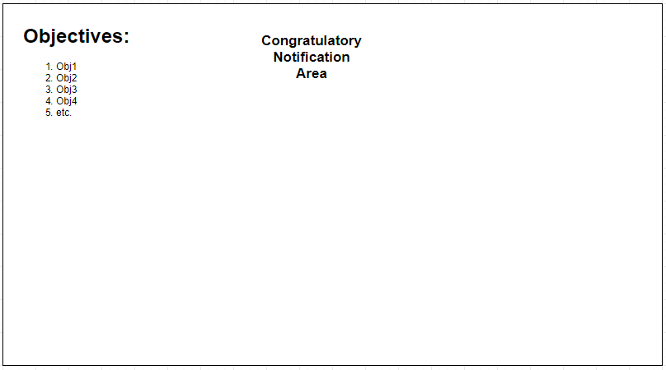

User Input Flowchart

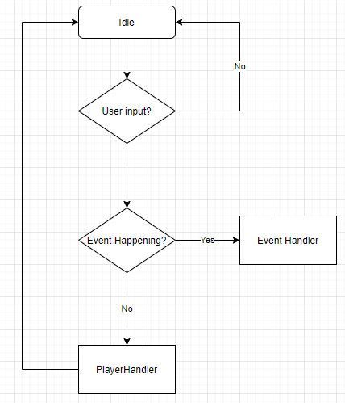

1. Use the template to list the project deliverables.

|  |  |  |  |  |  |
| --- | --- | --- | --- | --- | --- |
| Deliverable Acceptance Log | | | | | |
| ID | Deliverable Description | Comments | Evaluator (internal or external as applicable) | Status | Date of Decision |
| 1 | UI Wireframes | Wireframes for the planned UI of the Main Menu and the OCD level | Carson Perry | Complete | 02/18 |
| 2 | User Input Flowchart | Flowchart for how user input is interpreted and sent | Carson Perry | Complete | 04/04 |
| 3 |  |  |  |  |  |
| 4 |  |  |  |  |  |
| 5 |  |  |  |  |  |

|  |
| --- |
| Detail Solution Architecture |

1. The User will be able to choose which level to load from the main menu. This will begin to load assets that the level requires and set the scene. The only model classes used in the scenes will be an Event handler (an object that will be used to detect alarms, and collisions with event causing areas) and the Player class model as well. There is no need for other models, as the Event Handler can control and manipulate multiple objects in the scene, and is the only model we need for scene objects. There won’t be any need for software setup, however hardware wise, there are some specs required for running this game. Unity games require an Operating system of Windows 7 SP1+, macOS 10.12+, or Ubuntu 16.04+. The CPU must be able to handle SSE2 instruction sets, and the graphics card (GPU) should be capable of using DX10.

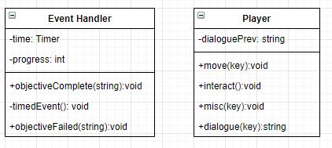

1. With this being a completely offline, single-player video game, there’s little to do with security. However, on the main site where this game will be distributed, I will provide and md5 checksum. This is often used to ensure that a program hasn’t been tampered with after downloading. This will help people make sure they have the correct version in case they get it from somewhere else.
2. Use the template to list the hardware and software technologies.

|  |
| --- |
| Hardware and Software Technologies |
| 1 - Windows 7 SP1+, macOS 10.12+, or Ubuntu 16.04+ |
| 2 – CPU that can handle SSE2 instruction sets |
| 3 - GPU capable of using DX10 |
| 4 – Unity Game Engine |
| 5 – FL Studio |
| 6 - Blender |

|  |
| --- |
| Revision and Signoff Sheet |

**Change Record**

|  |  |  |
| --- | --- | --- |
| **Date** | **Editor** | **Revision Notes** |
| 04/04/21 | Carson Perry | Initial draft for review/discussion |
|  |  |  |
|  |  |  |

|  |
| --- |
| **Overall Instructor Feedback/Comments** |